BANNER

Menu Bar

November E-news

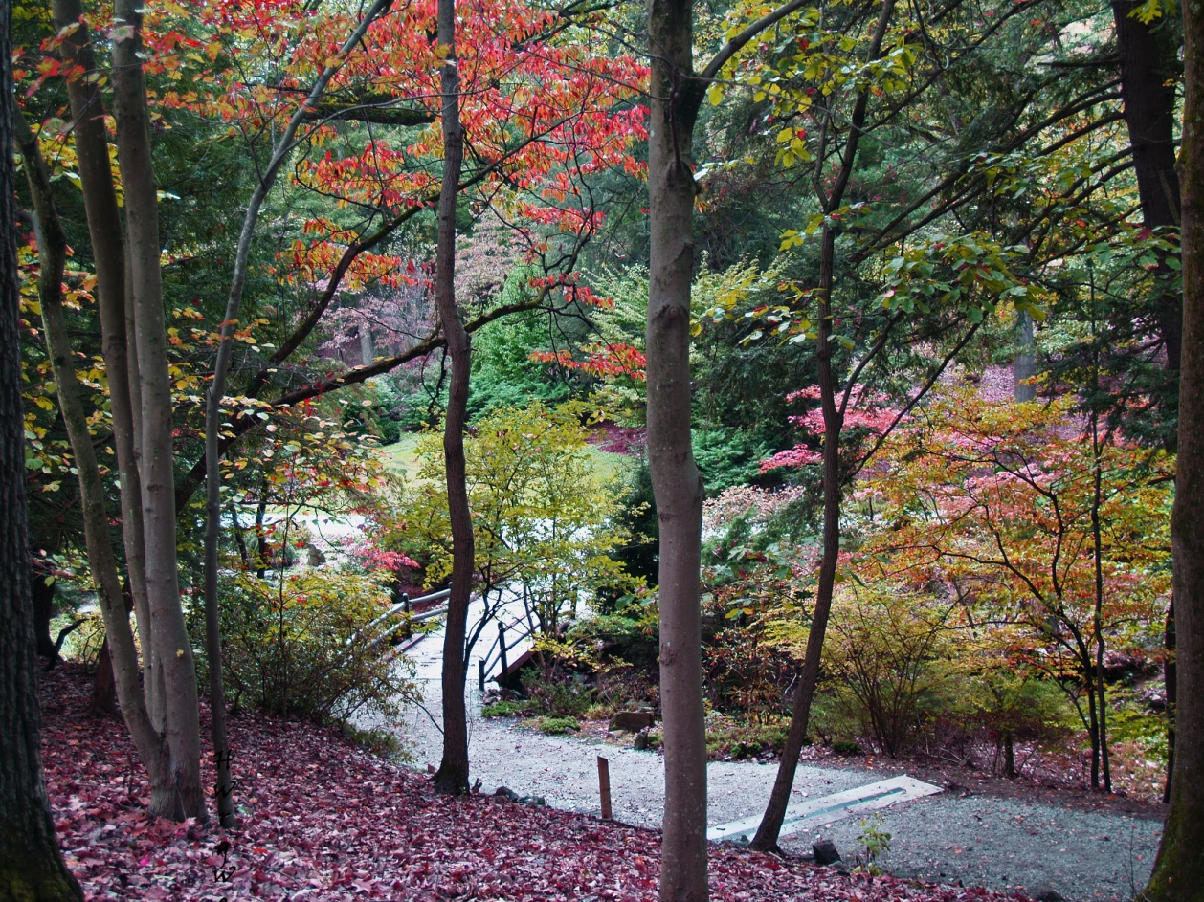

*Photo by Heather Hayden*

**Savor the sights, sounds and fragrances of fall in the arboretum.**

Barb – Nov 2020 you broke the annual meeting flyer into (2) boxes to conserve space

2021 ANNUAL MEETING FLYER

Sculpture Trail News

**New Installations**

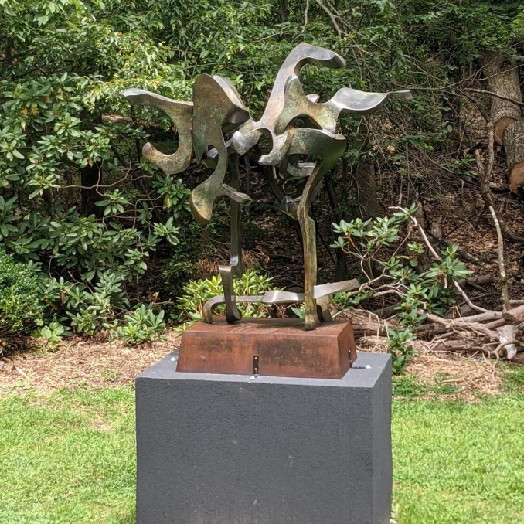 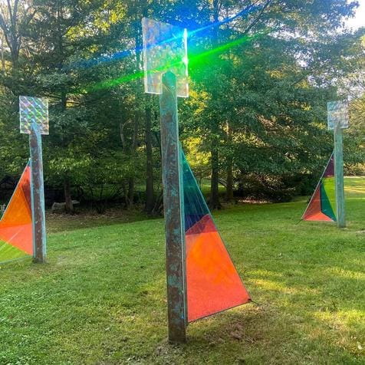

Abstraction in Flight by Bill Barrett In Awe of Light by Patricia Lavin and John Ritchie

Box below about 14C and News 12 interview – links visible for you

 ***A Sculpture Trail*** at Laurelwood Arboretum will be represented by Broadfoot and Broodfoot Galleries at the Art Fair 14C in Jersey City Nov. 12 – 14.

**Click here** for more information about the Art Fair**.** [**https://artfair14c.com/**](https://artfair14c.com/)

**Click here** to watch a News 12 NJ interview with Scott Broadhead on *A Sculpture Trail.* <https://newjersey.news12.com/art-and-nature-laurelwood-arboretum-adds-new-sculpture-walking-tour>.

**Box this as it was in last E-news**

**Join this Exciting Fundraising Effort!**

**Become a Sculpture Trail Sponsor\***

**OR**

**Buy a Digital Ad**

**\* Many sponsorships include ads**

[Become a Sponsor](https://laurelwoodarboretum.us12.list-manage.com/track/click?u=40e97c843c427a24fbce7fcc0&id=2e8d4bb889&e=cf1304c294)

[View the Ad Journal](https://laurelwoodarboretum.us12.list-manage.com/track/click?u=40e97c843c427a24fbce7fcc0&id=1518d9cca3&e=cf1304c294)

[Click here to learn more about the Sculpture Trail](https://laurelwoodarboretum.us12.list-manage.com/track/click?u=40e97c843c427a24fbce7fcc0&id=25c4d6c7b8&e=cf1304c294)  
  
Click here to see*A Sculpture Trail* on Instagram  
[https://www.instagram.com/laurelwoodsculpturetrl/](https://laurelwoodarboretum.us12.list-manage.com/track/click?u=40e97c843c427a24fbce7fcc0&id=d68f372c65&e=cf1304c294).

**____________________________________________________________________**

**Tours**

**Tours of the arboretum and the Sculpture Trail continue to be popular.**

**Visitors from Abroad**

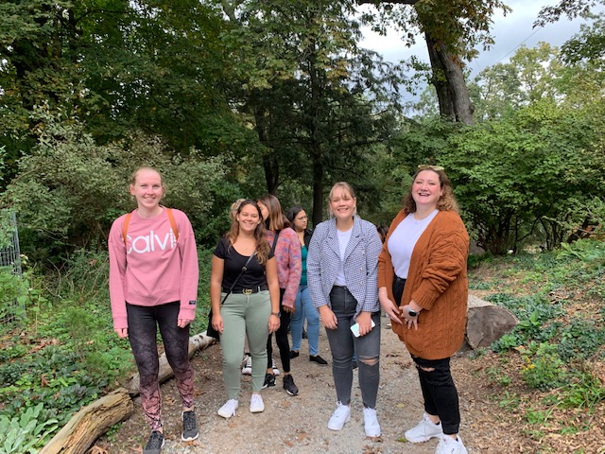

*Photo by Richard Santoro*

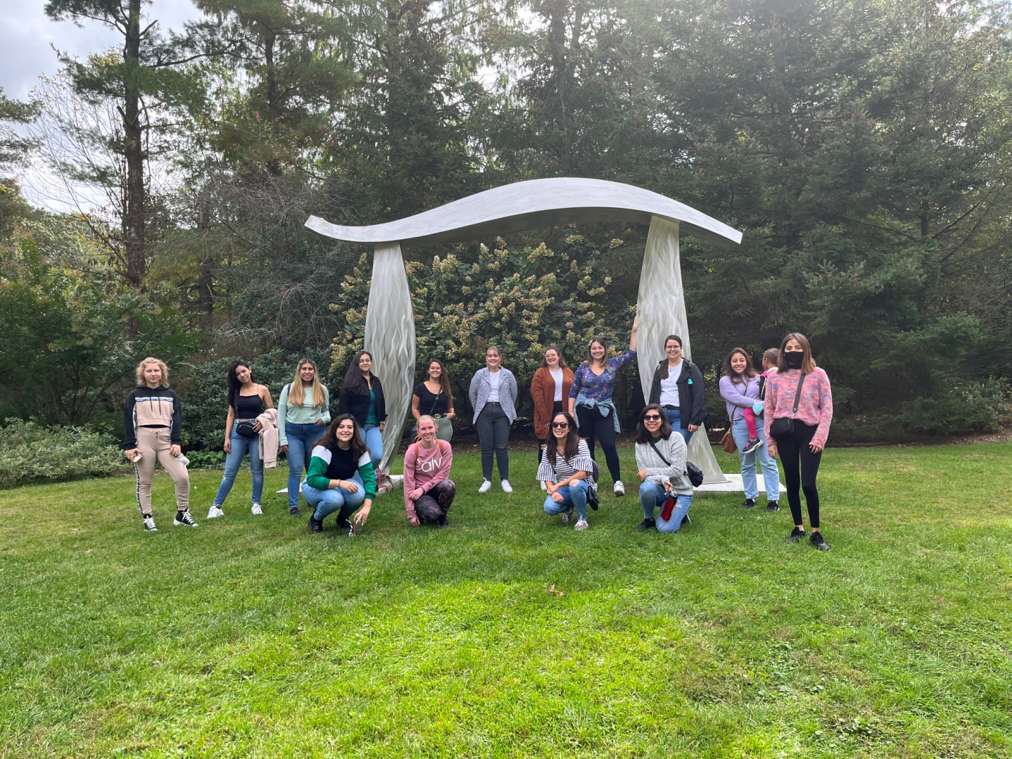 At Pi in the Sky *Photo by Jessica Liva*

Bonnie Joachim and Richard Santoro led a tour for a group of au pairs staying with local families. The au pairs came from Brazil, Mexico, South Africa, Netherlands, Croatia, Ecuador and Columbia. Everyone enjoyed the park, sculptures and getting to know each other. The visit was arranged by Au Pair U.S.A. Local Coordinator Jessica Liva.

………………………………………………………………………………………………….

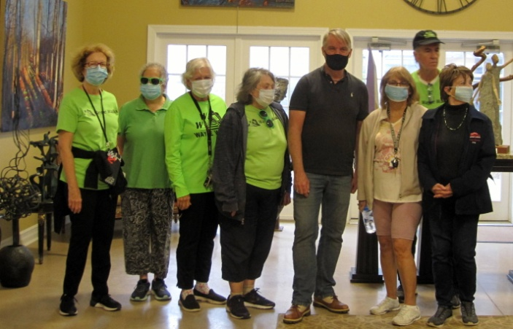 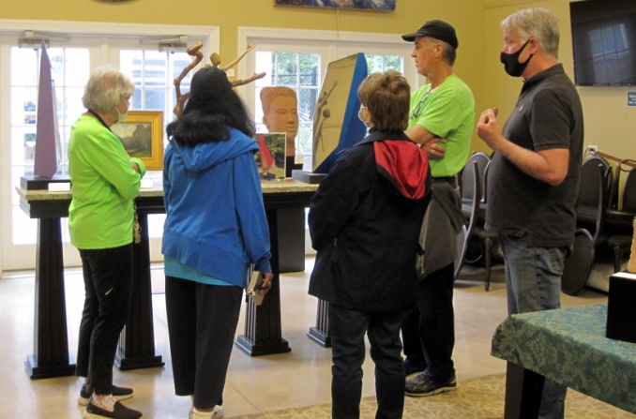Scott Broadhead led a group of Wayne Walkers on a Sculpture Trail tour that ended in the Knippenberg Center and small sculpture display.

**Learning About Medicinal Plants**

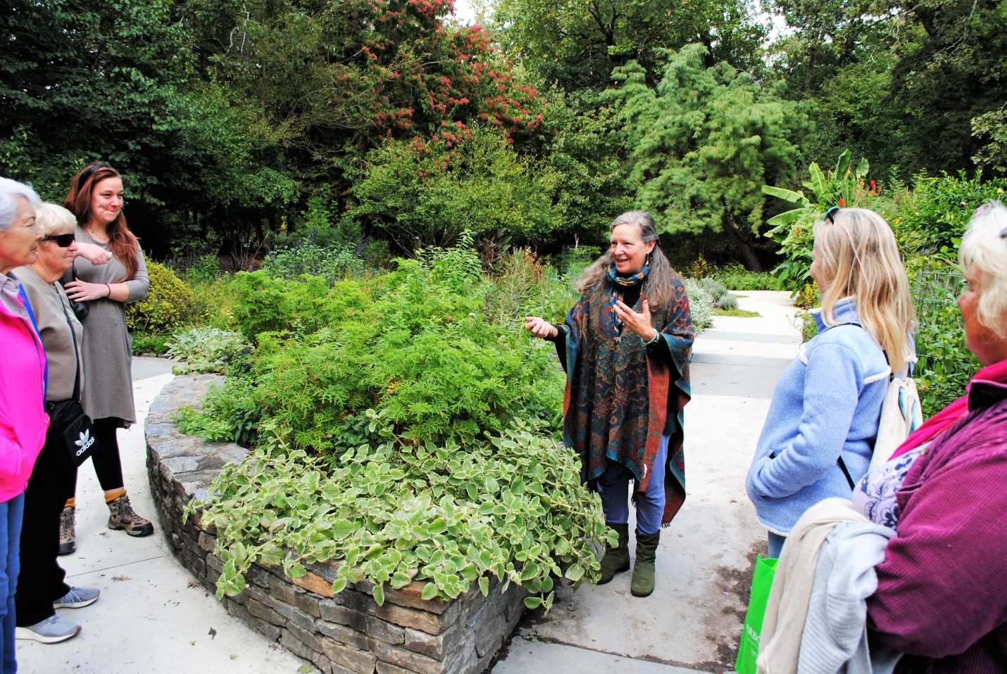

*Photo by Lorraine Meyer*

Renowned herbalist Robin Rose Bennett led two fall "Weed Walks” through Laurelwood.

“We smudged, sang and meditated with plants,” she said. “The 30 walkers learned identification skills and a number of ways to use common weeds for food and medicine.” Bennett generously donated the proceeds from the second walk to Friends of Laurelwood Arboretum.

_____________________________________________________________________-

**Box the Tree Stories blurb above the grapefruit story**

**Tree Stories**

**Trees play an important role throughout our lives. Share your tree story with us all! Send to** [**info@laurelwoodarboretum.org**](mailto:info@laurelwoodarboretum.org)

**This a story about a Grapefruit Tree**

*Peter A. Marcalus*

*September 5, 2021*

In February 1975, it was the final semester of my senior year attending a boarding school called Northfield Mt. Hermon. The school was located in Mt. Hermon, Massachusetts near the New Hampshire and Vermont boarder. That cold and snowy winter, my parents had sent me a gift box full of fresh Florida oranges and grapefruits to share with my dorm mates.

While eating one of the flavorful, juicy grapefruits, I found a spouted seed. I planted the little seedling in a paper cup and kept it watered and in a sunny window in my dorm room. After graduation that spring, I packed up my belongings along with the little grapefruit seedling and returned to my parent’s home in Wyckoff.

Throughout my college years, the grapefruit seedling mostly stayed in Wyckoff where my mother regularly watered it until I’d come home for holidays and summer breaks to resume caring for the little plant. In my senior college year, the seedling joined me in an off-campus apartment.

With each passing year, the little grapefruit slowly grew and I progressively replanted it into bigger and bigger pots.

When I got married, the grapefruit plant moved with me and my bride to our new home in Hawthorne where I continued to nurture the plant. Eventually we saw the little sapling going through what we jokingly called “puberty” as the tree’s dark green trunk got thicker and formed a smooth gray bark.

As the plant got larger and became hardier, it would summer outside in the back yard and then before the first autumn frost, I’d moved it back inside for the winter. After being indoors all winter the sapling always would lose quite a few leaves and look very weak. Then each Mother’s Day, it would go back outside to the spring sunshine, where it would perk back up. After about a month, it would always fill out quite nicely with tender new leaves and branches.

**Click here to continue reading….**

In 1984 my wife and I moved to Oakland. With each passing year the sapling got bigger and I continued to transplant it into even larger pots. Eventually, each autumn before going back inside for the winter, the sapling’s summer growth would have to be trimmed so it could fit through the house doors. The tree’s freshly cut branches and leaves would emit a wonderful citrus odor. While our family grew, the little tree never had blossoms or formed any fruit.

Tending the grapefruit tree became a labor of love and its seasonal care was a ritual. As the tree got heavier, I’d have to recruit friends and family to help me move the tree inside or outside depending on the season. Sometimes during the winter months, the tree’s pot would leak water on the rugs in our home and if not caught quickly, create staining and minor damage. On occasion, my wife would shake her head at my devoted care of the grapefruit tree. One time she even evoked a halfhearted threat to get rid of the tree while I was at work. That threat was jokingly countered by me saying that I’ve had the tree longer we’d been married and the tree would not be the first one to go!

As the tree got too big to go thru the doors of my Oakland home, I moved it to my office which had larger commercial doors and higher ceilings. For several years it was exclusively an indoor “office plant” living inside a multi-story building next to a well-lit window.

When I had a career change, the tree moved with me to the new company. There I was able to move the grapefruit tree into a new office space where again it wintered indoors and then the tree enjoyed being moved outside to a sunny court yard during the spring, summer and early autumn.

So, for 13 years, the tree lived in that new “home” where I continued to nurture its growth until in March 2020 when I retired. Not wanting to leave my tree behind where I knew it would not be properly cared for, I was able to find housing for the grapefruit tree at a local public library. Unfortunately, during the Covid lock down and for many months thereafter, it became evident the tree was being neglected and needed more care otherwise it was soon going to die.

It just so happened that since the early days of the pandemic, my wife and I had become regular visitors to Laurelwood Arboretum. During Covid, the arboretum offered the freedom of outdoor exercise and the safety of social distancing all in a wonderfully landscaped environment, with interesting plants and trees (many of which are identified with tags) as well as thought provoking sculpture positioned in beautiful lawned areas.

Knowing my tree was in great need of a new home where people knew how to take care of plants, I asked Laurelwood Arboretum if they would accept my grapefruit tree as a donation. They graciously accepted the tree and in September 2021 for the last time, I recruited friends to help move the tree to the arboretum.

Over the last 46 years since I first discovered that little sprouted seed in that delicious grapefruit, it has lived at a boarding school, a college apartment, three north Jersey homes, two office buildings and in one public library. It’s never produced a citrus fruit or even a single flower. The tree has been transplanted at least a dozen times into ever increasing larger pots, nearly been tossed out by an irate wife for being a carpet wetter and like Jack London’s character Buck from *Call Of The Wild*, the tree was thought forgotten, mistreated, and almost died.

So that’s the story of *my* grapefruit tree. I hope it will spend many healthy years at Laurelwood. At times the tree might take a bit of work. It needs weekly watering, occasional fertilizing and trimming as well as seasonally, it needs to be muscled in and out the door. But it will give back great beauty with its glossy deep green leaves, twisting branches seeking sunlight and a wonderful citrus fragrance. And who knows…maybe with continued TLC and someone with a greener thumb than mine, I like to think that tree will reward its new caretaker with the gift of a grapefruit. And wouldn’t it be nice if that grapefruit also contains the magic of a newly spouted seedling.

**Volunteer News**

*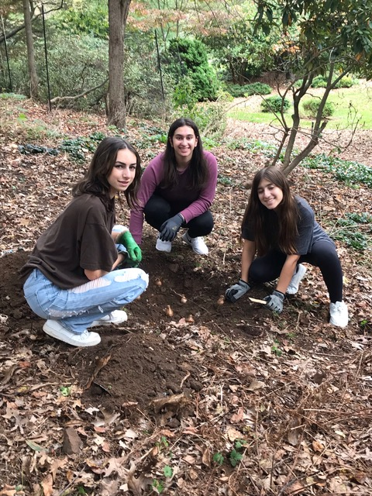 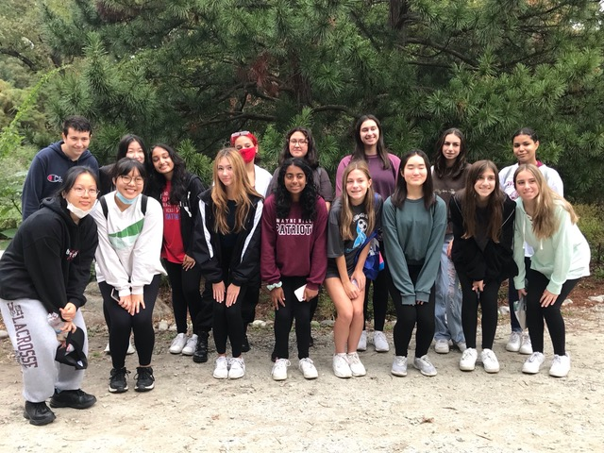 Photos by Carol Palmer-Yomtov*

Members of the Wayne Hills High School Leo Club spent a morning at Laurelwood with the group’s advisor, teacher Jessica Fishman. They planted 200 or more bulbs that will brighten the arboretum next Spring. The Wayne Lions Club’s Leo Club Program gives young people the opportunity to serve their communities and make a positive impact.

**...........................................................................................................................................**

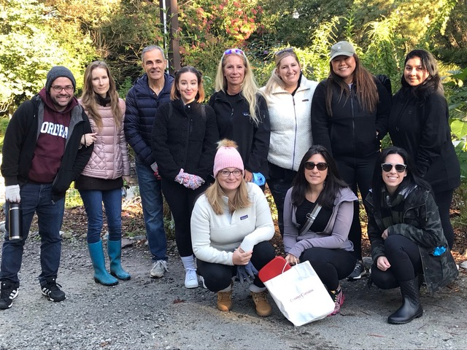

Volunteers from Wyndham Hotels & Resorts spent a morning planting bulbs.

………………………………………………………………………………………………….

**Rhododendron Propagation Team**

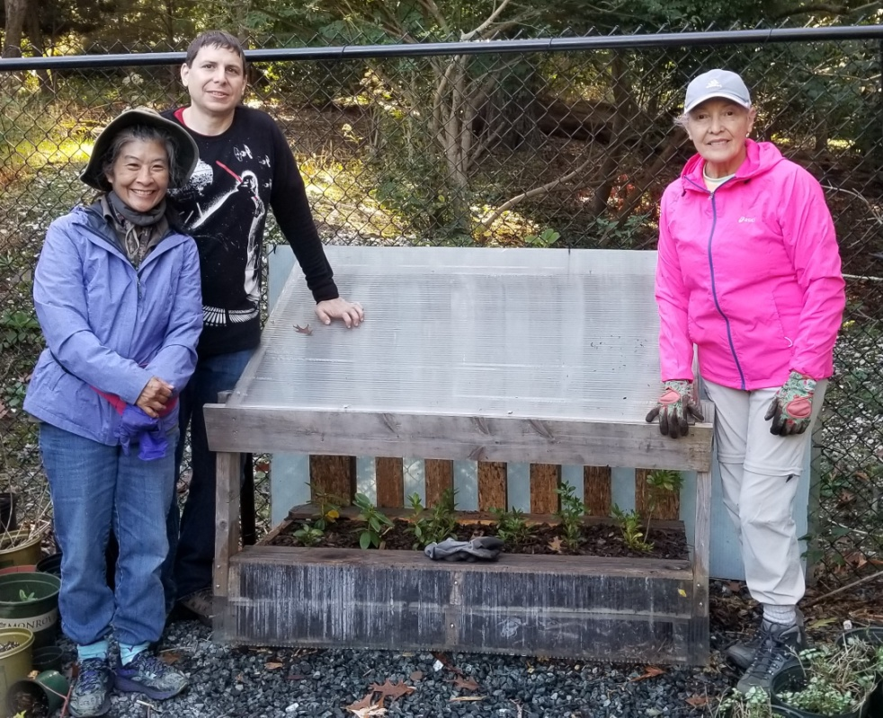

Sean Hartman, Carol Heimbach and Edith Coka-Jordi.

Our rhododendron propagation team has been busy during September and October taking stem cuttings from several of our historically significant rhododendrons for propagation. In all, 92 stem cuttings were placed in rooting containers in our propagation greenhouse where, hopefully, roots will develop after about five months. The young plants will be potted and cared for in the greenhouse until they are ready to be planted in the arboretum. The team also recently prepared young ‘Laurelwood Sunset’ azaleas that had been propagated from stem cuttings last year for overwintering in our cold frame. *Joe Di Giacomo*

…………………………………………………………………………………………………..

**Native Plant Garden Team**

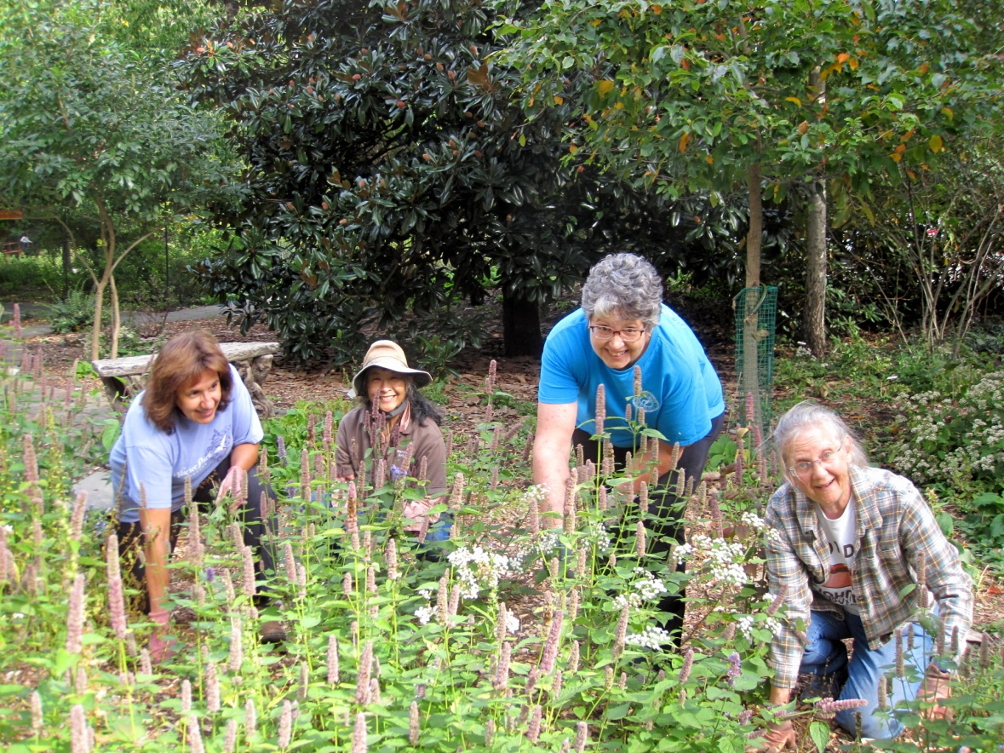o

Lourdes Osorio leads volunteers in the native plant garden on a Saturday morning. From left are Lourdes, Carol Heimbach and Susan Pivetz.

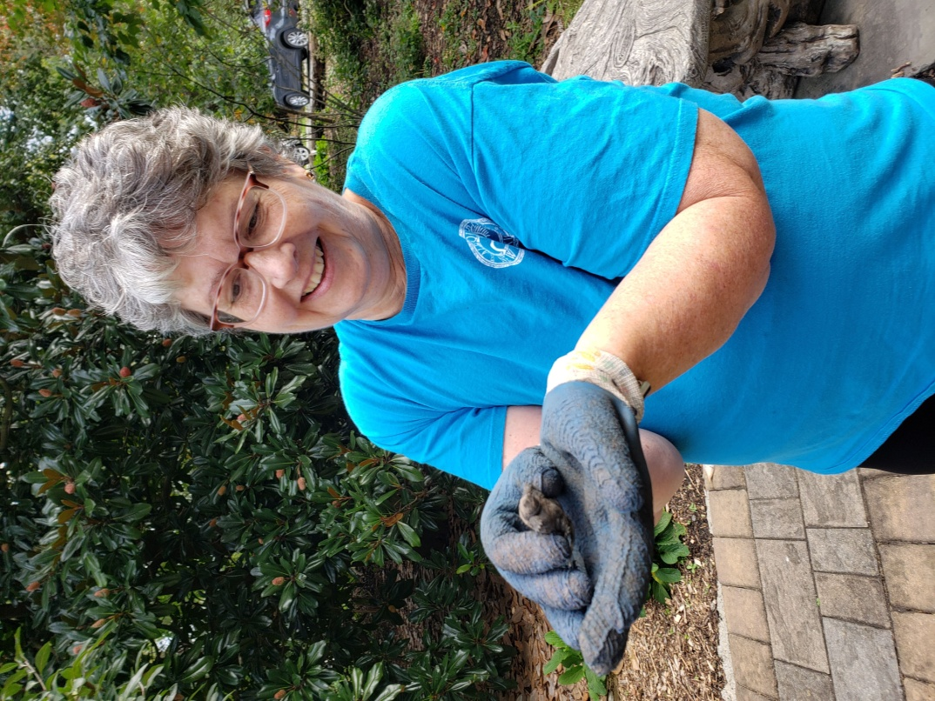

Susan Pivetz discovers a baby turtle on a walkway

and relocates it to a safe area.

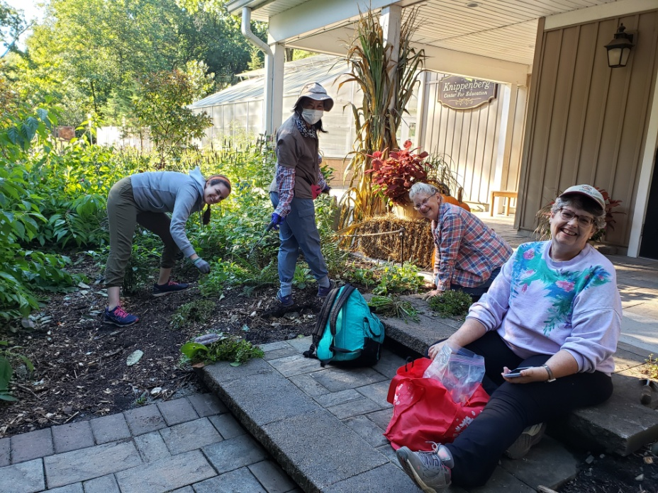

Native plant garden volunteers weed the front of the KCE.

Left to right: Meghan Seradsky, Carol Heimbach, Marilyn Lenat, and Susan Pivetz.

………………………………………………………………………………………………………

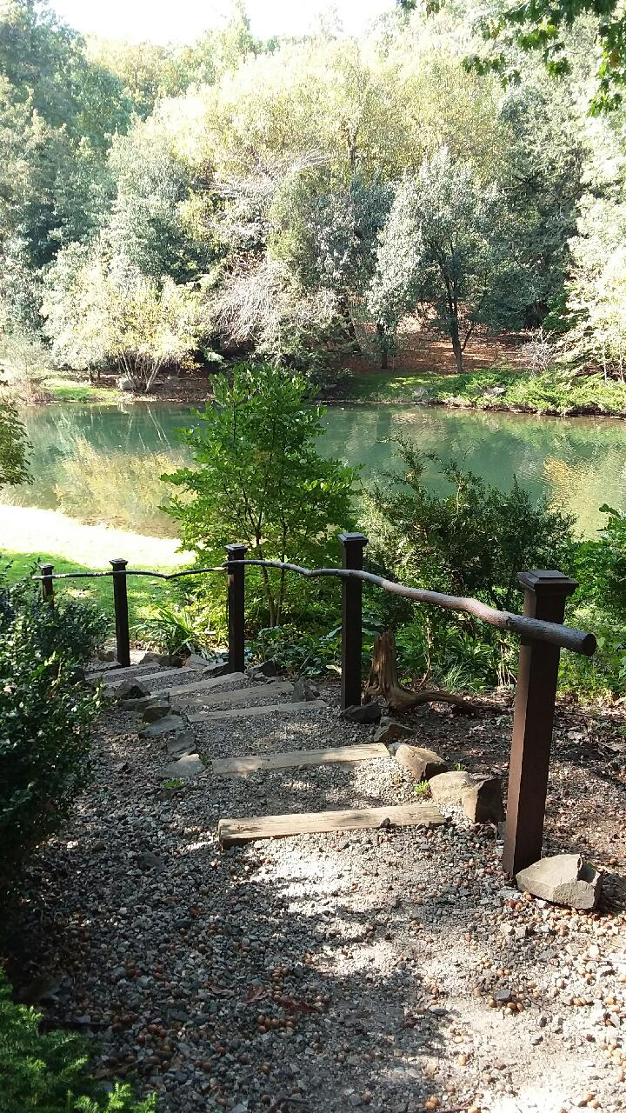 *Photo by Joan Scott Miller*

Longtime volunteer Dick Watts recently installed a hand-hewn railing for easier access to the Laurel Pond shoreline and Martha Walker’s sculpture, “Dyad.”

…………………………………………………………………………………………………..

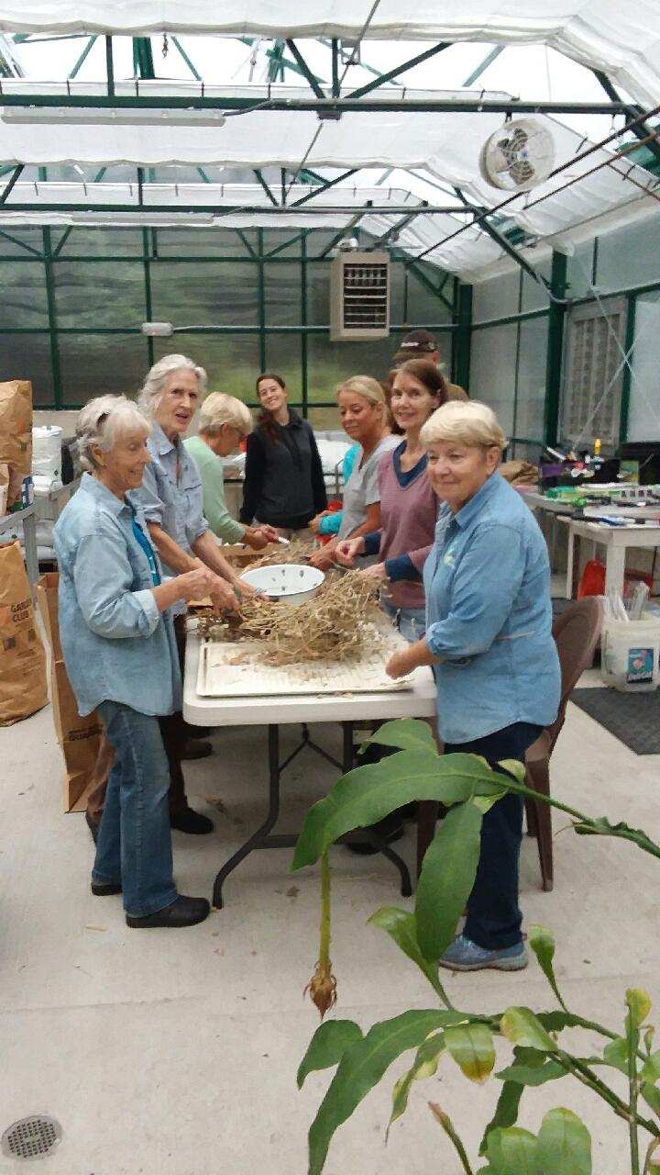

During a sudden thunderstorm, volunteers retreated to the propagation greenhouse and set to work sorting seeds.

On left are Nancy Fadynich, Nancy Alexander and Susy Libert. Staff member Kay Gardiner is in the center.

On the right are Gerry Lowry, Kathy Mattick and Heidi Herc. Not in photo are Warren Phillips, Gary Molan and Sean Hartman.

……………………………………………………………………………………………

**Spreading the word about Laurelwood at Wayne Day.**

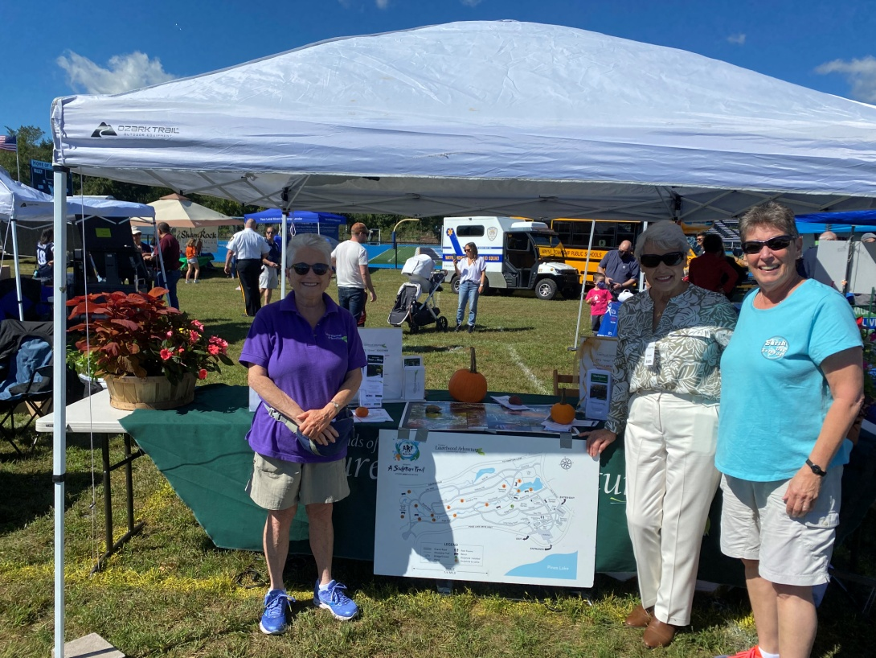 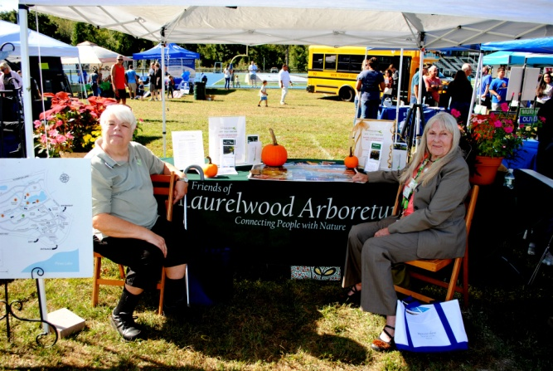

Left: Carol Palmer-Yomtov, Edith Coka-Jordi and Georgette Moesch.

Right: Nancy Shimmel and Jane Van Eeuwen

………………………………………………………………………………………………………..

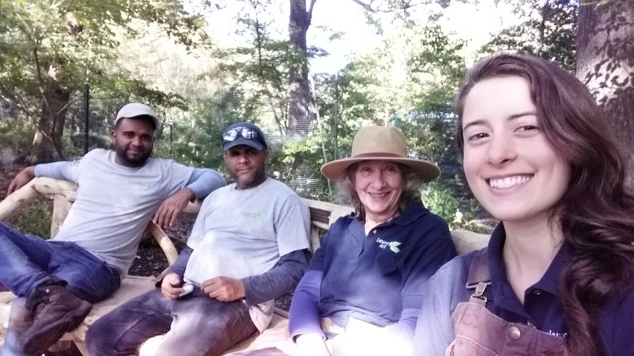

Staff members Eddy Lantigua, Felix Fernandez, Joan Scott-Miller and Kay Gardiner take a rest break on the new David Robinson bench on azalea way.

………………………………………………………………………………………………

**Volunteer Spotlight**

**Nancy Shimmel**

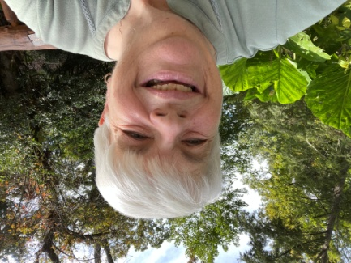 For the past three years, Nancy Shimmel has served on the Board of Directors as Recording Secretary, taking minutes of all executive committee and board meetings. This is no easy task, because discussions are sometimes lengthy and wide-ranging, but Nancy’s minutes are always accurate.

A dedicated gardener, Nancy works in the Sensory Garden in the summer and in the greenhouse during the winter months. She also volunteers at our plant sale, on the program committee, as a weekend greeter and whenever there is a call for help at any of our events. “I'm fortunate to have my family nearby so they can join me in special programs (especially my two grandchildren), as well as spending time together walking through the arboretum to appreciate its beauty throughout the year,” she said.

Nancy retired after a 25-year career as a Family & Consumer Science (Home Economics) teacher at Ramapo- Indian Hills and Pompton Lakes high schools. One Saturday morning, she read about the Rutgers Master Gardener class in Ray Edel's column in *The Record*. “It sounded interesting, so I applied. Through that program, I learned of Laurelwood,” Nancy said. “As I look back at my first few years volunteering there, I'm amazed at the changes, especially in the area of the South Rock Garden, construction of the Knippenberg Center and the opening of the propagation greenhouse. I feel so honored and fortunate to be a part of the Laurelwood family of staff and volunteers—a group of very special people—and to contribute to the beauty and serenity we find in Laurelwood.”

**-u**

____________________________________________________________

**We wish to thank** 

**For donating a full day of tree service in the arboretum.**

**____________________________________________________________**

**It’s nice to hear from you!**

**Praise for Tour Guide Gerry Lowry**

A big thank you to Gerry! We had a wonderful visit and although my children have been there many times, we all learned something new- a great morning!

Edvie Canavan

**_**

|  |  |  |  |  |  |  |  |  |  |  |  |  |  |  |  |  |  |  |  |  |  |  |  |  |  |  |  |  |  |  |  |  |  |  |  |  |  |  |  |  |  |  |
| --- | --- | --- | --- | --- | --- | --- | --- | --- | --- | --- | --- | --- | --- | --- | --- | --- | --- | --- | --- | --- | --- | --- | --- | --- | --- | --- | --- | --- | --- | --- | --- | --- | --- | --- | --- | --- | --- | --- | --- | --- | --- | --- |
| |  |  |  |  |  |  |  |  |  |  |  |  |  |  |  |  |  |  |  |  |  |  |  |  |  |  |  |  |  |  | | --- | --- | --- | --- | --- | --- | --- | --- | --- | --- | --- | --- | --- | --- | --- | --- | --- | --- | --- | --- | --- | --- | --- | --- | --- | --- | --- | --- | --- | --- | | |  |  | | --- | --- | | |  | | --- | |  | |  |  |  | | --- | --- | | |  | | --- | | youtube [Click here](https://laurelwoodarboretum.us12.list-manage.com/track/click?u=40e97c843c427a24fbce7fcc0&id=1f26f75ab0&e=cf1304c294) to see the Friends of Laurelwood Arboretum's YouTube channel with lots of great videos from the arboretum. | |  |  |  | | --- | --- | | |  | | --- | |  | |  |  |  | | --- | --- | | |  | | --- | | Amazon Smile Don't forget to "SMILE!!” | |  |  |  | | --- | --- | | |  | | --- | | Amazon, through the AmazonSmile Foundation, will contribute 0.5% of your purchases on Amazon to a charitable organization you select.  [Click here](https://laurelwoodarboretum.us12.list-manage.com/track/click?u=40e97c843c427a24fbce7fcc0&id=2edcf99911&e=cf1304c294) and log in to your Amazon account to designate the Friends of Laurelwood Arboretum as your charity. | |  |  |  | | --- | --- | | |  | | --- | |  | |  |  |  | | --- | --- | | |  | | --- | | VISIT OUR SOCIAL MEDIA PLATFORMS | |  |  |  |  |  |  |  |  |  |  | | --- | --- | --- | --- | --- | --- | --- | --- | --- | | |  |  |  |  |  |  |  |  | | --- | --- | --- | --- | --- | --- | --- | --- | | |  |  |  |  |  |  |  | | --- | --- | --- | --- | --- | --- | --- | | |  |  |  |  |  |  | | --- | --- | --- | --- | --- | --- | | |  | | --- | | [Like us on Facebook](https://laurelwoodarboretum.us12.list-manage.com/track/click?u=40e97c843c427a24fbce7fcc0&id=2c58aecfa2&e=cf1304c294) |  |  | | --- | | [Twitter](https://laurelwoodarboretum.us12.list-manage.com/track/click?u=40e97c843c427a24fbce7fcc0&id=816bae35fb&e=cf1304c294) |  |  | | --- | | [Website](https://laurelwoodarboretum.us12.list-manage.com/track/click?u=40e97c843c427a24fbce7fcc0&id=e7d3c6d997&e=cf1304c294) |  |  | | --- | | [Instagram](https://laurelwoodarboretum.us12.list-manage.com/track/click?u=40e97c843c427a24fbce7fcc0&id=ed495213fc&e=cf1304c294) |  |  | | --- | | [YouTube](https://laurelwoodarboretum.us12.list-manage.com/track/click?u=40e97c843c427a24fbce7fcc0&id=99f0698a75&e=cf1304c294) | | | | |  |  |  | | --- | --- | | |  | | --- | |  | |  |  |  | | --- | --- | | |  | | --- | | Donations to Friends of Laurelwood Arboretum help to support the park's maintenance, operations and public programs.  Dues and donations are deductible for income tax purposes to the extent allowed by law,Friends of Laurelwood Arboretum is a 501(c)(3) non-profit organization. | |  |  |  | | --- | --- | | |  | | --- | | Please Support our Business Partners [Click here for more information](https://laurelwoodarboretum.us12.list-manage.com/track/click?u=40e97c843c427a24fbce7fcc0&id=bb69215986&e=cf1304c294) | | | | |  |  |  | | --- | --- | --- | | |  |  | | --- | --- | | |  | | --- | | [**Donate**](https://laurelwoodarboretum.us12.list-manage.com/track/click?u=40e97c843c427a24fbce7fcc0&id=c5ac90565f&e=cf1304c294) | | |  |  |  |  | | --- | --- | --- | | |  |  | | --- | --- | | |  | | --- | | [**Join/Renew**](https://laurelwoodarboretum.us12.list-manage.com/track/click?u=40e97c843c427a24fbce7fcc0&id=bc3b30879b&e=cf1304c294) | | | | | |  |  | | --- | --- | | |  | | --- | |  | |  |  |  | | --- | --- | | |  | | --- | | Copyright © 2021 Friends of Laurelwood Arboretum, All rights reserved. You are receiving this email because you asked to be on our email list.  **We are located at:**  Friends of Laurelwood Arboretum  725 Pines Lake Drive West  Wayne, NJ 07470  [Add us to your address book](https://laurelwoodarboretum.us12.list-manage.com/vcard?u=40e97c843c427a24fbce7fcc0&id=8844b753ca)  Want to change how you receive these emails? You can [update your preferences](https://laurelwoodarboretum.us12.list-manage.com/profile?u=40e97c843c427a24fbce7fcc0&id=8844b753ca&e=cf1304c294&c=a78423a2c2) or [unsubscribe from this list](https://laurelwoodarboretum.us12.list-manage.com/unsubscribe?u=40e97c843c427a24fbce7fcc0&id=8844b753ca&e=cf1304c294&c=a78423a2c2)  [Email Marketing Powered by Mailchimp](http://www.mailchimp.com/email-referral/?utm_source=freemium_newsletter&utm_medium=email&utm_campaign=referral_marketing&aid=40e97c843c427a24fbce7fcc0&afl=1) | | | |

**___________________**

**p art gallery on Saturdays and Sundays**